SQL Queries used in this Project

- CREATE DATABASE feesDB;
- show DATABASES;
- USE feesDB;
- CREATE TABLE students (
id INT AUTO_INCREMENT PRIMARY KEY,
name VARCHAR(100),
course VARCHAR(100),
total_fee DOUBLE,
fee_paid DOUBLE DEFAULT
);
- show tables;
- describe students;

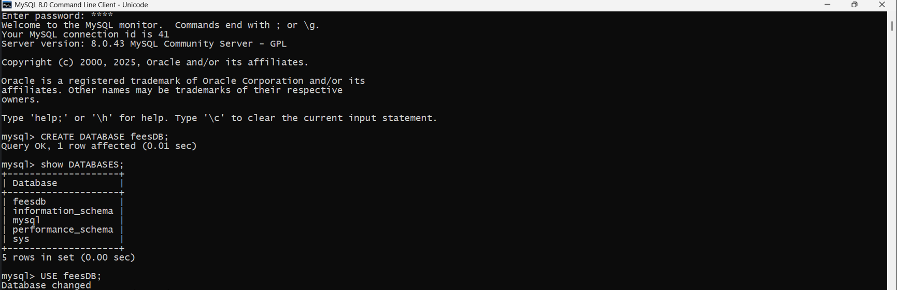
SQL Queries Screenshots Used in this Project
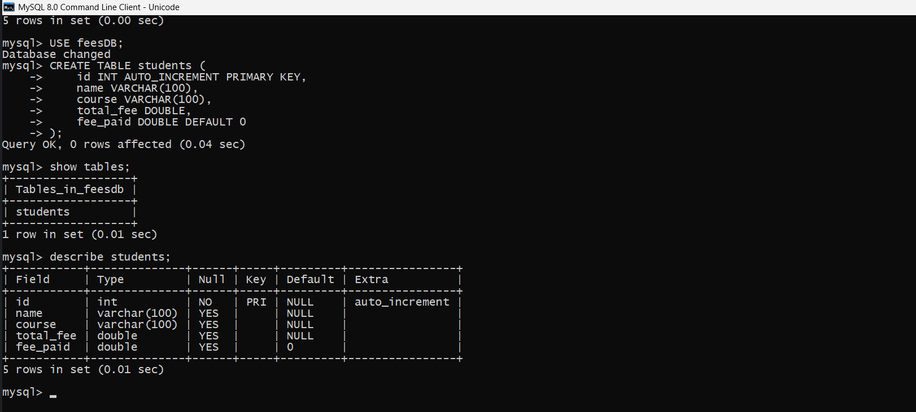

JAVA Code used in this Project
import java.sql.*;
import java.util.Scanner;

public class FeesManagementSystem {
static final String DB_URL = "jdbc:mysql://localhost:3306/FeesDB";
static final String USER = "root";
static final String PASS = "1234"; // <-- apna password yahan daalein

static Connection conn;
static Scanner sc = new Scanner(System.in);

public static void main(String[] args) {
try {
Class.forName("com.mysql.cj.jdbc.Driver");
conn = DriverManager.getConnection(DB_URL, USER, PASS);

// Create table if not exists
createTable();

while (true) {
System.out.println("\n=== Fees Management System ===");
System.out.println("1. Add Student Record");
System.out.println("2. View All Students");
System.out.println("3. Search Student");
System.out.println("4. Update Student");
System.out.println("5. Delete Student");
System.out.println("6. Fee Payment");
System.out.println("7. View Due Fees");
System.out.println("8. Exit");
System.out.print("Enter your choice: ");
int choice = Integer.parseInt(sc.nextLine());

switch (choice) {
case 1: addStudent(); break;
case 2: viewAllStudents(); break;
case 3: searchStudent(); break;
case 4: updateStudent(); break;
case 5: deleteStudent(); break;
case 6: feePayment(); break;
case 7: viewDueFees(); break;
case 8: System.out.println("Exiting..."); conn.close(); System.exit(0);
default: System.out.println("Invalid choice, try again.");
}
}

} catch (Exception e) {
e.printStackTrace();
}
}

static void createTable() throws SQLException {
String sql = "CREATE TABLE IF NOT EXISTS Students (" +
"id INT PRIMARY KEY AUTO_INCREMENT, " +
"name VARCHAR(50) NOT NULL, " +
"course VARCHAR(50) NOT NULL, " +
"fee_paid DECIMAL(10,2) DEFAULT 0, " +
"total_fee DECIMAL(10,2) NOT NULL)";
Statement stmt = conn.createStatement();
stmt.executeUpdate(sql);
stmt.close();
}

static void addStudent() throws SQLException {
System.out.print("Enter name: ");
String name = sc.nextLine();
System.out.print("Enter course: ");
String course = sc.nextLine();
System.out.print("Enter total fee: ");
double totalFee = Double.parseDouble(sc.nextLine());

String sql = "INSERT INTO Students (name, course, fee_paid, total_fee) VALUES (?, ?, 0, ?)";
PreparedStatement ps = conn.prepareStatement(sql);
ps.setString(1, name);
ps.setString(2, course);
ps.setDouble(3, totalFee);
int rows = ps.executeUpdate();
if (rows > 0) System.out.println("Student added successfully.");
else System.out.println("Failed to add student.");
ps.close();
}

static void viewAllStudents() throws SQLException {
String sql = "SELECT * FROM Students";
Statement stmt = conn.createStatement();
ResultSet rs = stmt.executeQuery(sql);
System.out.println("\nAll Students:");
while (rs.next()) {
System.out.printf("ID: %d, Name: %s, Course: %s, Fee Paid: %.2f, Total Fee: %.2f\n",
rs.getInt("id"), rs.getString("name"), rs.getString("course"), rs.getDouble("fee_paid"), rs.getDouble("total_fee"));
}
rs.close();
stmt.close();
}

static void searchStudent() throws SQLException {
System.out.print("Enter student ID to search: ");
int id = Integer.parseInt(sc.nextLine());
String sql = "SELECT * FROM Students WHERE id=?";
PreparedStatement ps = conn.prepareStatement(sql);
ps.setInt(1, id);
ResultSet rs = ps.executeQuery();
if (rs.next()) {
System.out.printf("ID: %d, Name: %s, Course: %s, Fee Paid: %.2f, Total Fee: %.2f\n",
rs.getInt("id"), rs.getString("name"), rs.getString("course"), rs.getDouble("fee_paid"), rs.getDouble("total_fee"));
} else {
System.out.println("Student not found.");
}
rs.close();
ps.close();
}

static void updateStudent() throws SQLException {
System.out.print("Enter student ID to update: ");
int id = Integer.parseInt(sc.nextLine());

// Check if student exists
String checkSql = "SELECT * FROM Students WHERE id=?";
PreparedStatement psCheck = conn.prepareStatement(checkSql);
psCheck.setInt(1, id);
ResultSet rs = psCheck.executeQuery();
if (!rs.next()) {
System.out.println("Student not found.");
rs.close();
psCheck.close();
return;
}
rs.close();
psCheck.close();

System.out.print("Enter new name: ");
String name = sc.nextLine();
System.out.print("Enter new course: ");
String course = sc.nextLine();
System.out.print("Enter new total fee: ");
double totalFee = Double.parseDouble(sc.nextLine());

String sql = "UPDATE Students SET name=?, course=?, total_fee=? WHERE id=?";
PreparedStatement ps = conn.prepareStatement(sql);
ps.setString(1, name);
ps.setString(2, course);
ps.setDouble(3, totalFee);
ps.setInt(4, id);

int rows = ps.executeUpdate();
if (rows > 0) System.out.println("Student updated successfully.");
else System.out.println("Update failed.");
ps.close();
}

static void deleteStudent() throws SQLException {
System.out.print("Enter student ID to delete: ");
int id = Integer.parseInt(sc.nextLine());

String sql = "DELETE FROM Students WHERE id=?";
PreparedStatement ps = conn.prepareStatement(sql);
ps.setInt(1, id);
int rows = ps.executeUpdate();
if (rows > 0) System.out.println("Student deleted successfully.");
else System.out.println("Student not found.");
ps.close();
}

static void feePayment() throws SQLException {
System.out.print("Enter student ID for fee payment: ");
int id = Integer.parseInt(sc.nextLine());

String sqlCheck = "SELECT fee_paid, total_fee FROM Students WHERE id=?";
PreparedStatement psCheck = conn.prepareStatement(sqlCheck);
psCheck.setInt(1, id);
ResultSet rs = psCheck.executeQuery();

if (!rs.next()) {
System.out.println("Student not found.");
rs.close();
psCheck.close();
return;
}

double feePaid = rs.getDouble("fee_paid");
double totalFee = rs.getDouble("total_fee");
rs.close();
psCheck.close();

System.out.printf("Fee Paid: %.2f, Total Fee: %.2f\n", feePaid, totalFee);
System.out.print("Enter amount to pay: ");
double amount = Double.parseDouble(sc.nextLine());

if (amount <= 0) {
System.out.println("Invalid amount.");
return;
}

if (feePaid + amount > totalFee) {
System.out.println("Payment exceeds total fee. Transaction cancelled.");
return;
}

String sqlUpdate = "UPDATE Students SET fee_paid = fee_paid + ? WHERE id=?";
PreparedStatement psUpdate = conn.prepareStatement(sqlUpdate);
psUpdate.setDouble(1, amount);
psUpdate.setInt(2, id);

int rows = psUpdate.executeUpdate();
if (rows > 0) System.out.println("Fee payment successful.");
else System.out.println("Fee payment failed.");

psUpdate.close();
}

static void viewDueFees() throws SQLException {
String sql = "SELECT id, name, course, (total_fee - fee_paid) AS due_fee FROM Students WHERE total_fee > fee_paid";
Statement stmt = conn.createStatement();
ResultSet rs = stmt.executeQuery(sql);

System.out.println("\nStudents with Due Fees:");
boolean anyDue = false;
while (rs.next()) {
anyDue = true;
System.out.printf("ID: %d, Name: %s, Course: %s, Due Fee: %.2f\n",
rs.getInt("id"), rs.getString("name"), rs.getString("course"), rs.getDouble("due_fee"));
}
if (!anyDue) System.out.println("No students with due fees.");
rs.close();
stmt.close();
}
}

JAVA Code Screenshot used in this Project

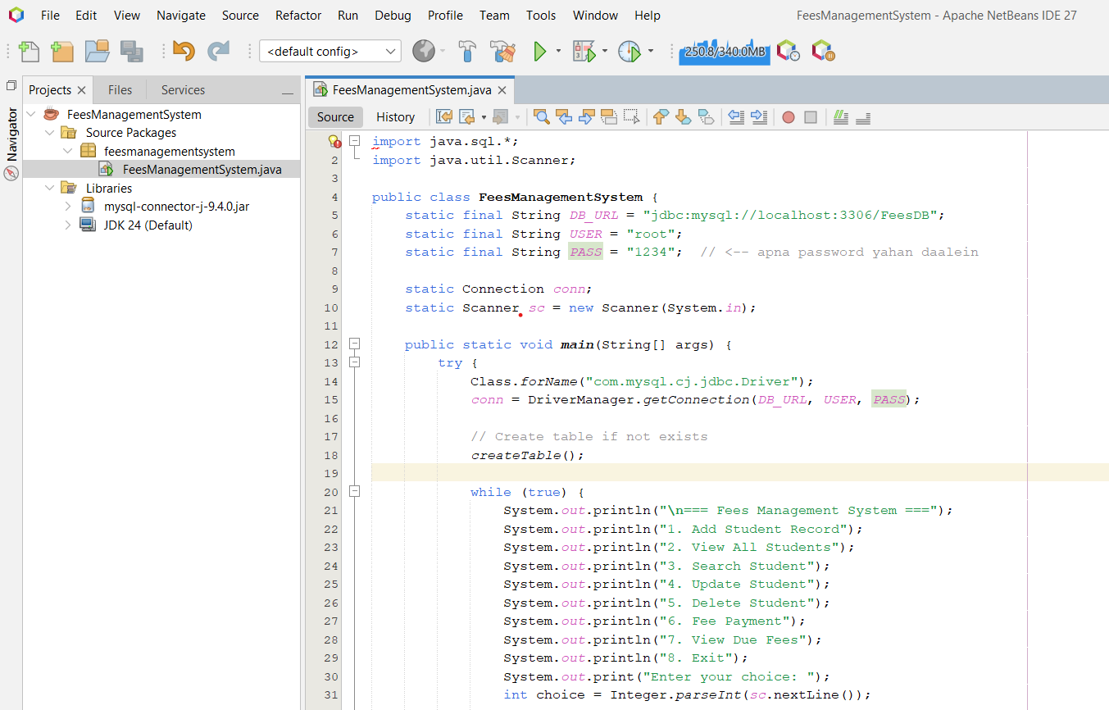

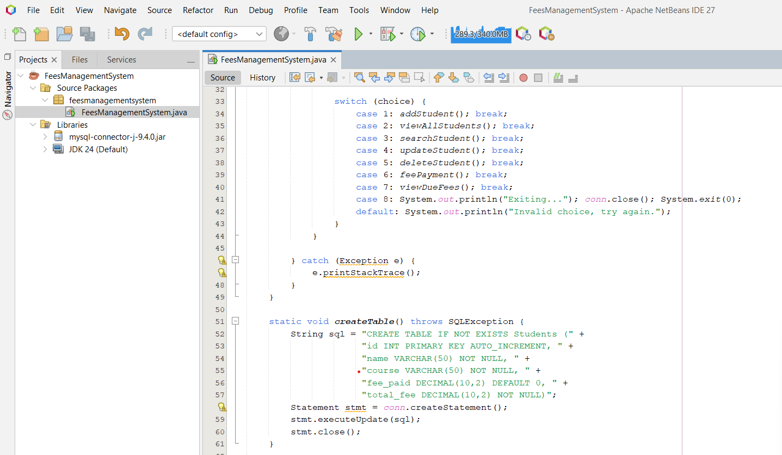
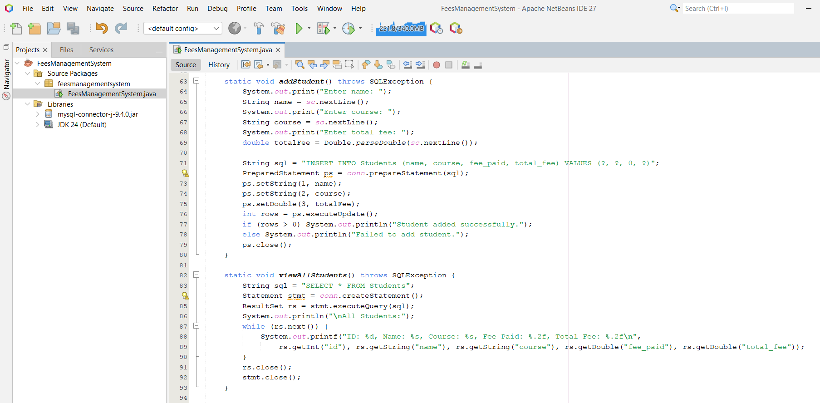
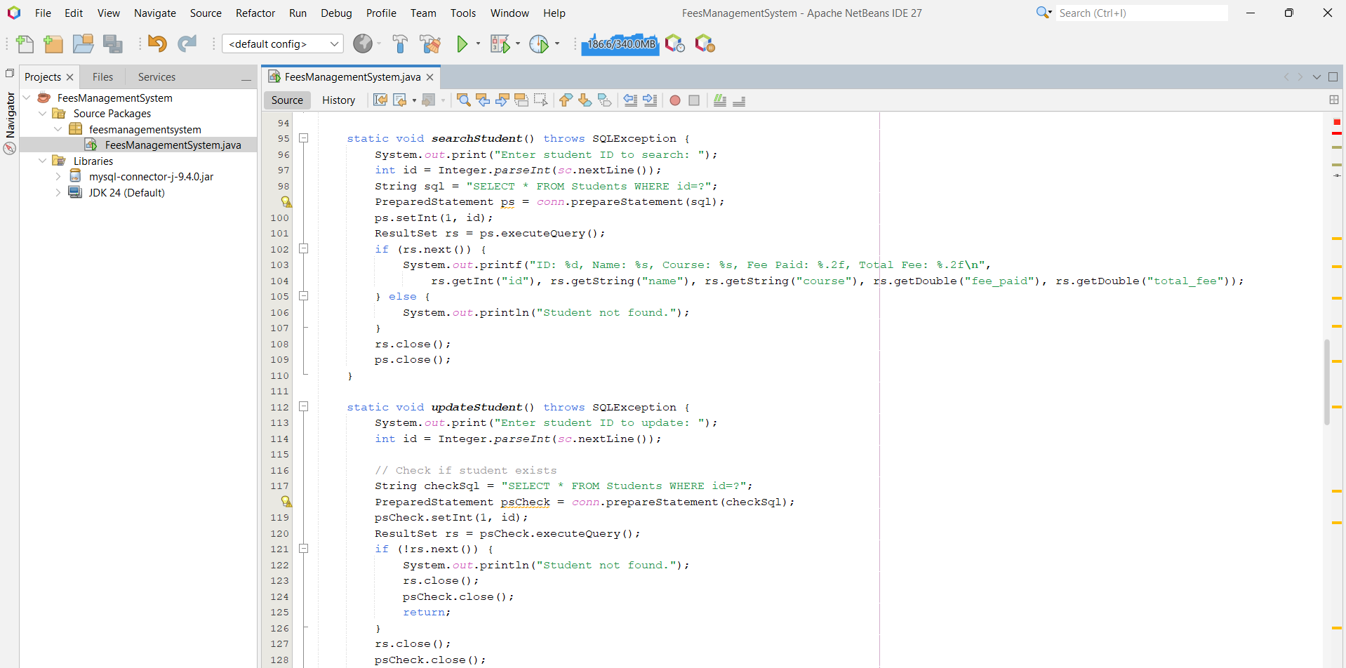

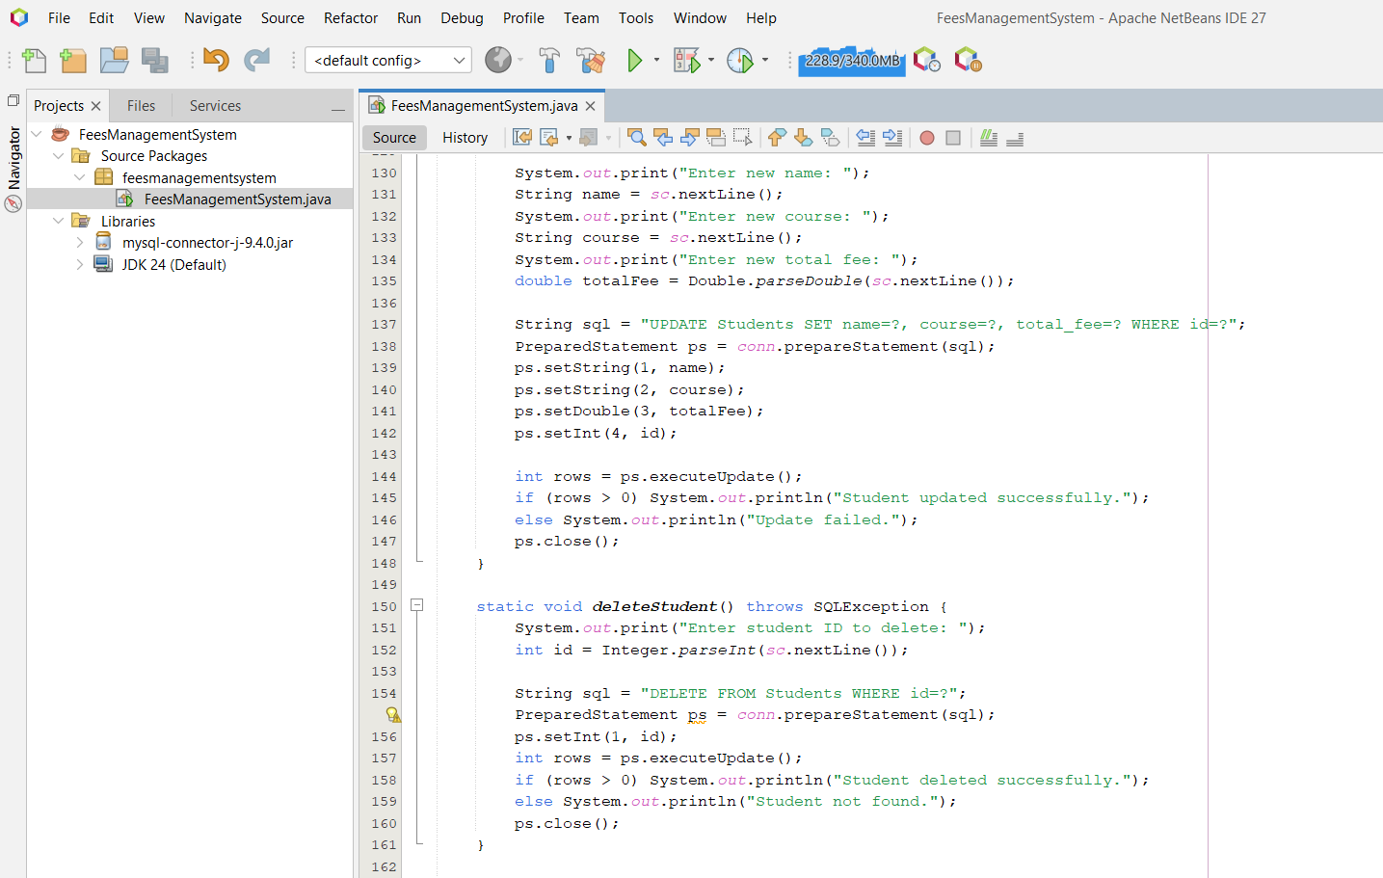

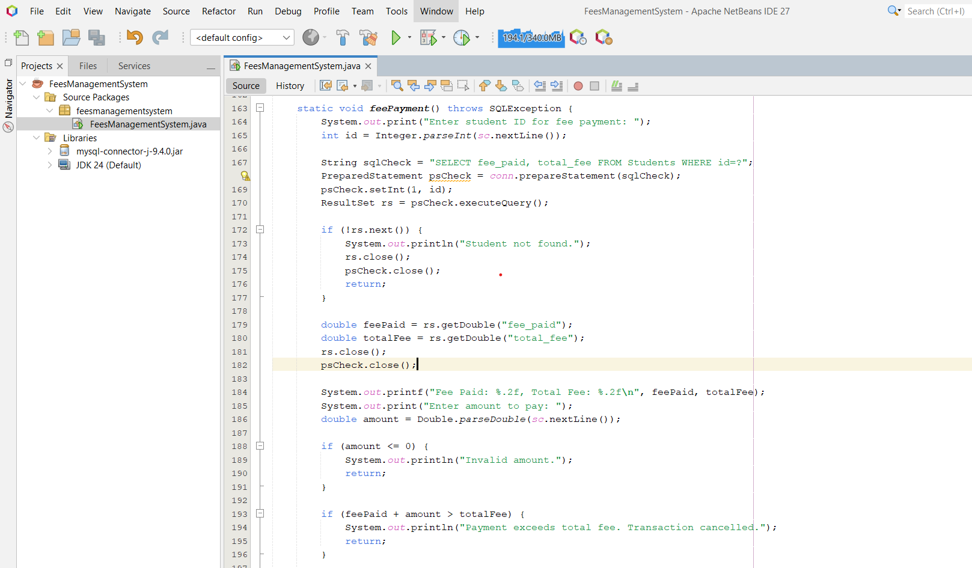

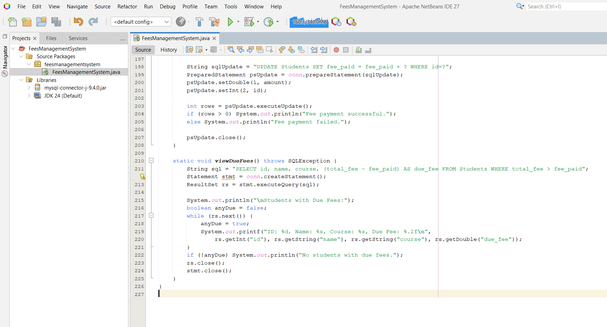
PROJECT OUTPUT SCREENSHOTS
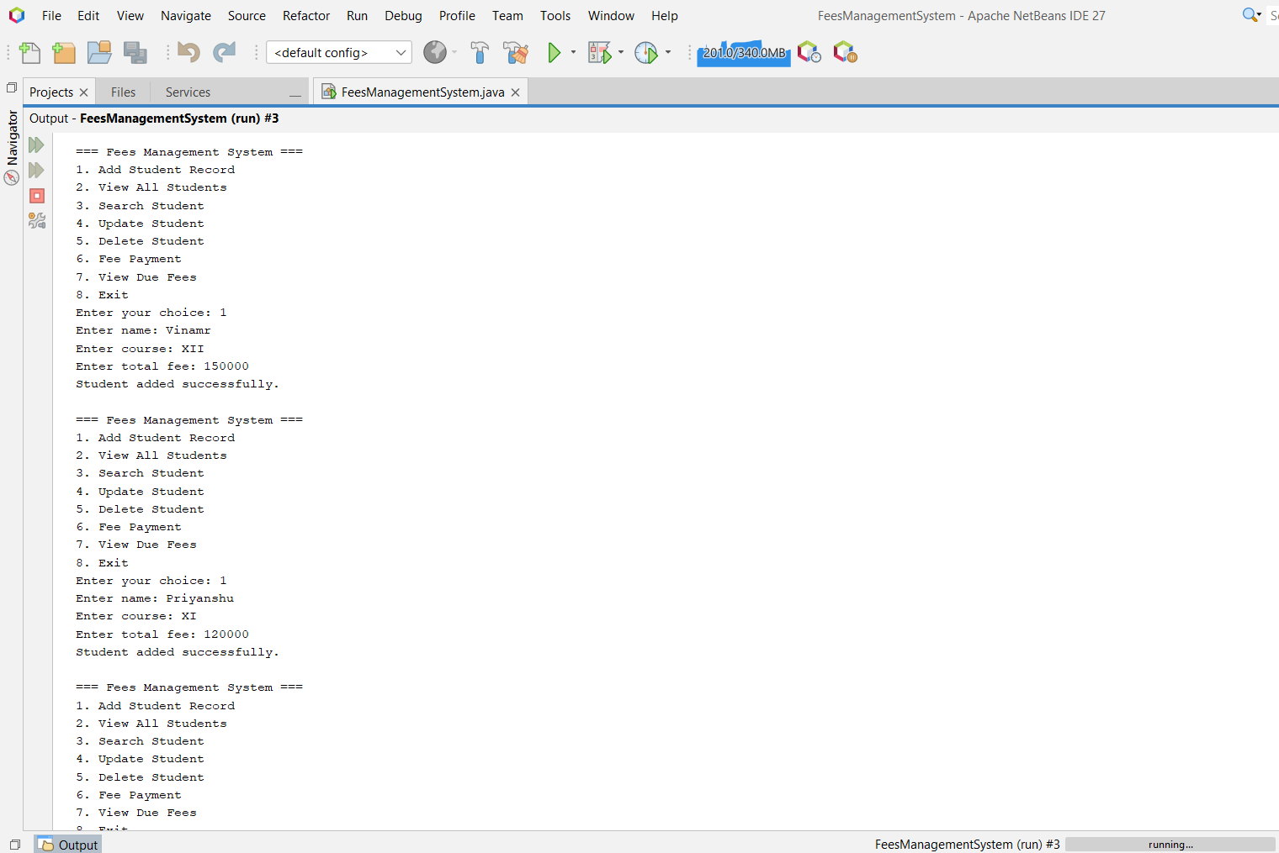
1. Add the students details:

2. View and Search the student details:
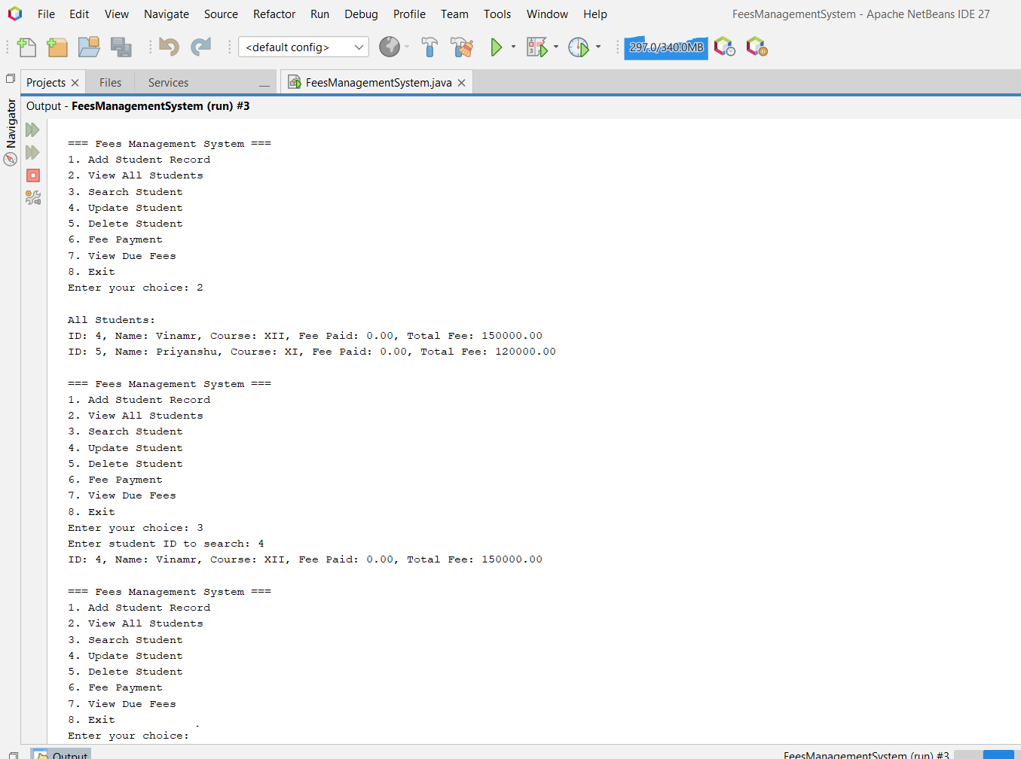
3. Update and Search the Student Details:
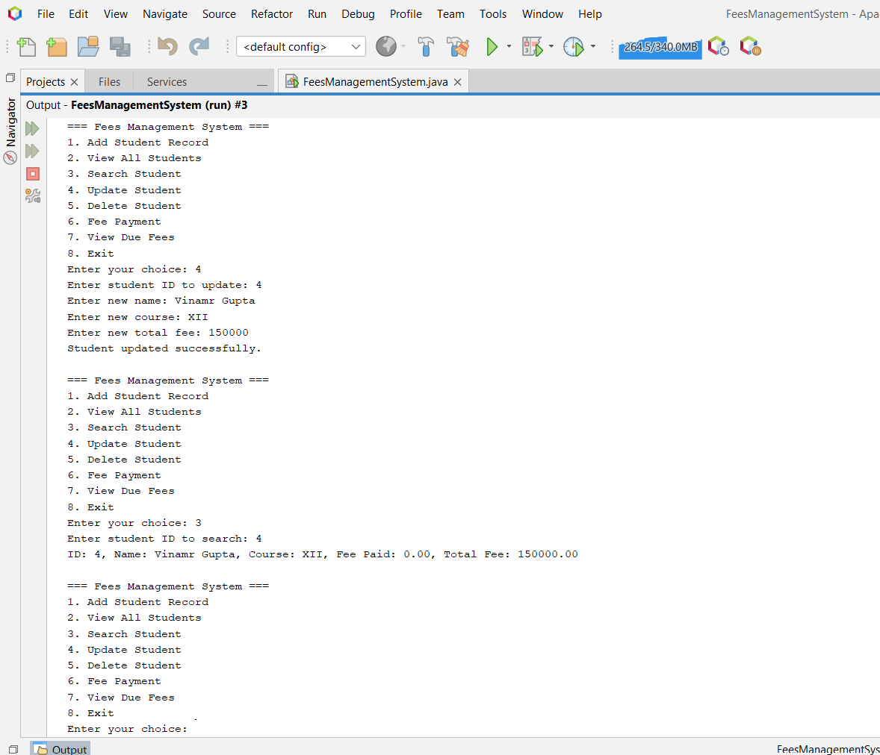
4. Fee Payment and View Due Fees:
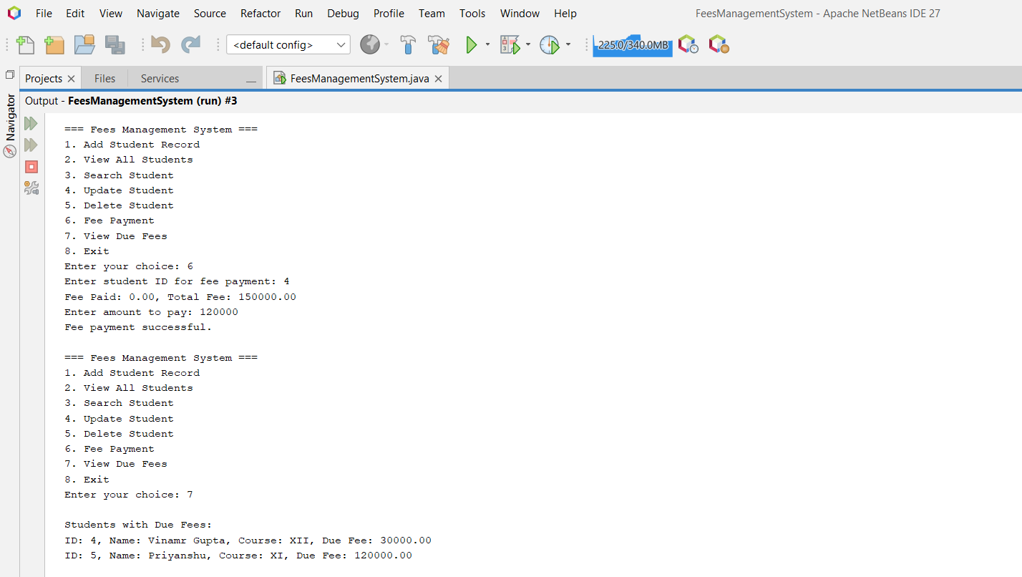

DATABASE OUTPUT SCREENSHOTS
